LAB INTERNAL EXAMINATION – E-COMMERCE PRODUCT MANAGEMENT

Experiment – 1: Create and Insert Product
Aim
To create a Product Entity in a Spring Boot application and implement a REST API to insert product details into a PostgreSQL database. The API is tested using Postman, and at least two products are inserted and verified in the database.

Software Requirements
- Java JDK 21
- Spring Boot
- Maven
- PostgreSQL
- Postman
- IntelliJ IDEA / Spring Tool Suite / VS Code

Technologies Used
- Backend: Spring Boot
- Programming Language: Java
- Database: PostgreSQL
- ORM: Spring Data JPA / Hibernate
- API Testing: Postman
- Build Tool: Maven

1. Project Creation
Create a new Spring Boot project with the following configuration:
Property | Value
Project | Maven
Language | Java
Group | com.klu
Artifact | ecommerce-backend
Packaging | Jar
Java | 21
Required Dependencies
Add the following dependencies:
- Spring Web
- Spring Data JPA
- PostgreSQL Driver
- Spring Boot DevTools
- SpringDoc OpenAPI
2. Database Configuration
Create a PostgreSQL database named:
CREATE DATABASE ecommerce_db1;
After creating the database, configure the database connection in:
src/main/resources/application.properties
program:
spring.application.name=ecommerce-backend
spring.datasource.url=jdbc:postgresql://localhost:5432/ecommerce_db1
spring.datasource.username=postgres
spring.datasource.password=root

spring.jpa.hibernate.ddl-auto=update
spring.jpa.show-sql=true
spring.jpa.properties.hibernate.format_sql=true

server.port=8080

3. Project Structure
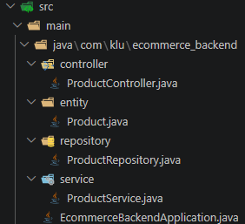
The request flow is:
Postman
↓
ProductController
↓
ProductService
↓
ProductRepository
↓
PostgreSQL Database

4. Create Product Entity
package com.klu.ecommerce_backend.entity;
import jakarta.persistence.*;
import java.math.BigDecimal;

@Entity
@Table(name = "products")
public class Product {

@Id
@GeneratedValue(strategy = GenerationType.IDENTITY)
private Long productId;

private String productName;
private String category;
private String description;
private BigDecimal price;
private Integer stock;
private String imageUrl;
private Double rating;
private String status;

public Product() {
}

public Long getProductId() {
return productId;
}

public void setProductId(Long productId) {
this.productId = productId;
}

public String getProductName() {
return productName;
}

public void setProductName(String productName) {
this.productName = productName;
}

public String getCategory() {
return category;
}

public void setCategory(String category) {
this.category = category;
}

public String getDescription() {
return description;
}

public void setDescription(String description) {
this.description = description;
}

public BigDecimal getPrice() {
return price;
}

public void setPrice(BigDecimal price) {
this.price = price;
}

public Integer getStock() {
return stock;
}

public void setStock(Integer stock) {
this.stock = stock;
}

public String getImageUrl() {
return imageUrl;
}

public void setImageUrl(String imageUrl) {
this.imageUrl = imageUrl;
}

public Double getRating() {
return rating;
}

public void setRating(Double rating) {
this.rating = rating;
}

public String getStatus() {
return status;
}

public void setStatus(String status) {
this.status = status;
}
}

5. Create Product Repository
Create the package:
package com.klu.ecommerce_backend.repository;

import com.klu.ecommerce_backend.entity.Product;
import org.springframework.data.jpa.repository.JpaRepository;

public interface ProductRepository extends JpaRepository<Product, Long> {
}
6.Create Product Service
package com.klu.ecommerce_backend.service;
import com.klu.ecommerce_backend.entity.Product;
import com.klu.ecommerce_backend.repository.ProductRepository;
import org.springframework.stereotype.Service;
@Service
public class ProductService {
private final ProductRepository productRepository;
public ProductService(ProductRepository productRepository) {
this.productRepository = productRepository;
}
public Product addProduct(Product product) {
return productRepository.save(product);
}
}
7. Create Prpackage com.klu.ecommerce_backend.controller;
import com.klu.ecommerce_backend.entity.Product;
import com.klu.ecommerce_backend.service.ProductService;
import org.springframework.http.HttpStatus;
import org.springframework.http.ResponseEntity;
import org.springframework.web.bind.annotation.*;
@RestController
@RequestMapping("/api/products")
public class ProductController {
private final ProductService productService;
public ProductController(ProductService productService) {
this.productService = productService;
}
@PostMapping
public ResponseEntity<Product> addProduct(@RequestBody Product product) {

Product savedProduct = productService.addProduct(product);

return new ResponseEntity<>(savedProduct, HttpStatus.CREATED);
}
}
oduct Controller

8. Run the Application
Run the main Spring Boot application
EcommerceBackendApplication.java
The application should start successfully on:
http://localhost:8080
The console should show that the Spring Boot application has started successfully.
Hibernate will create or update the products table automatically because of:
spring.jpa.hibernate.ddl-auto=update

9. Test API Using Postman
Open Postman.
Select:
Method: POST
Enter the URL:
http://localhost:8080/api/products
Go to:
Body → raw → JSON
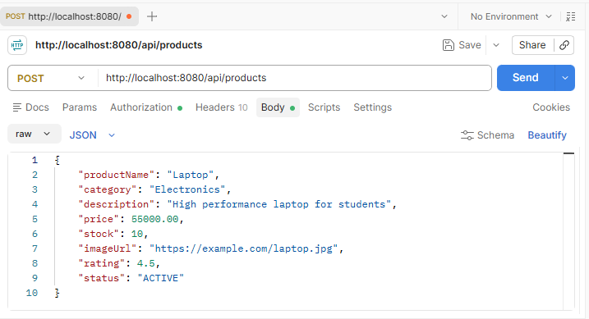

Product 1
Send the following JSON:
{
"productName": "Laptop",
"category": "Electronics",
"description": "High performance laptop for students",
"price": 55000.00,
"stock": 10,
"imageUrl": "https://example.com/laptop.jpg",
"rating": 4.5,
"status": "ACTIVE"
}
Click:
Send
Expected Response
{
"productId": 1,
"productName": "Laptop",
"category": "Electronics",
"description": "High performance laptop for students",
"price": 55000.00,
"stock": 10,
"imageUrl": "https://example.com/laptop.jpg",
"rating": 4.5,
"status": "ACTIVE"
}
The response status should be:
201 Created
11. Verify Products in PostgreSQL
Open PostgreSQL and connect to the database:
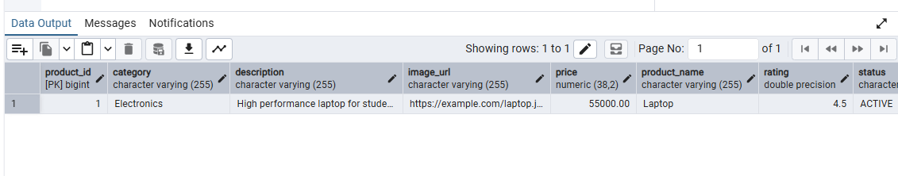
12. Result
The Product Entity was successfully created using Spring Data JPA. A REST API was implemented to insert product details into the PostgreSQL database. Two products were successfully added using Postman and verified in the products table.
Therefore, the experiment "Create and Insert Product" was successfully completed.

